Carmen Mendoza

CSD 340

Module 3.2 Assignment

For the verification I uploaded my file from computer:

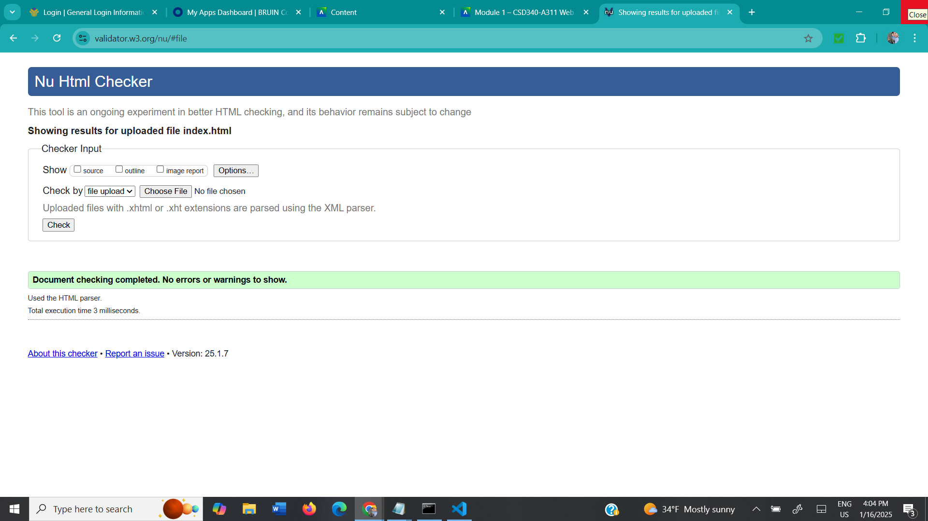

I also used the same method of uploading the file for the CSS. File:

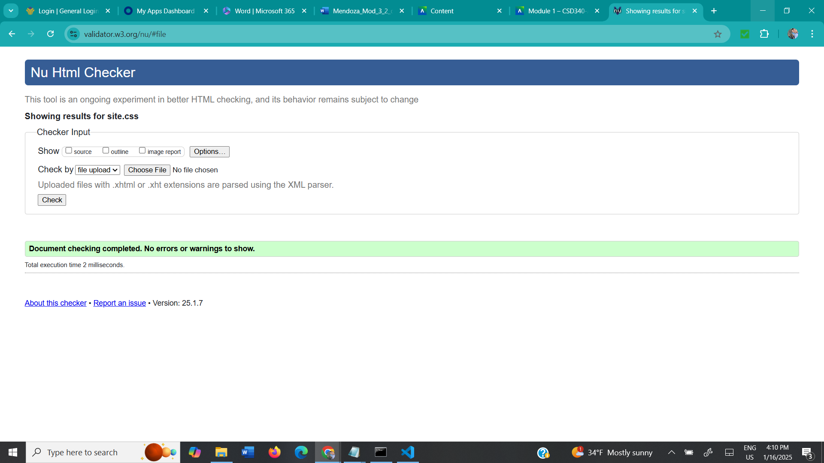

Screenshot of my landing page: 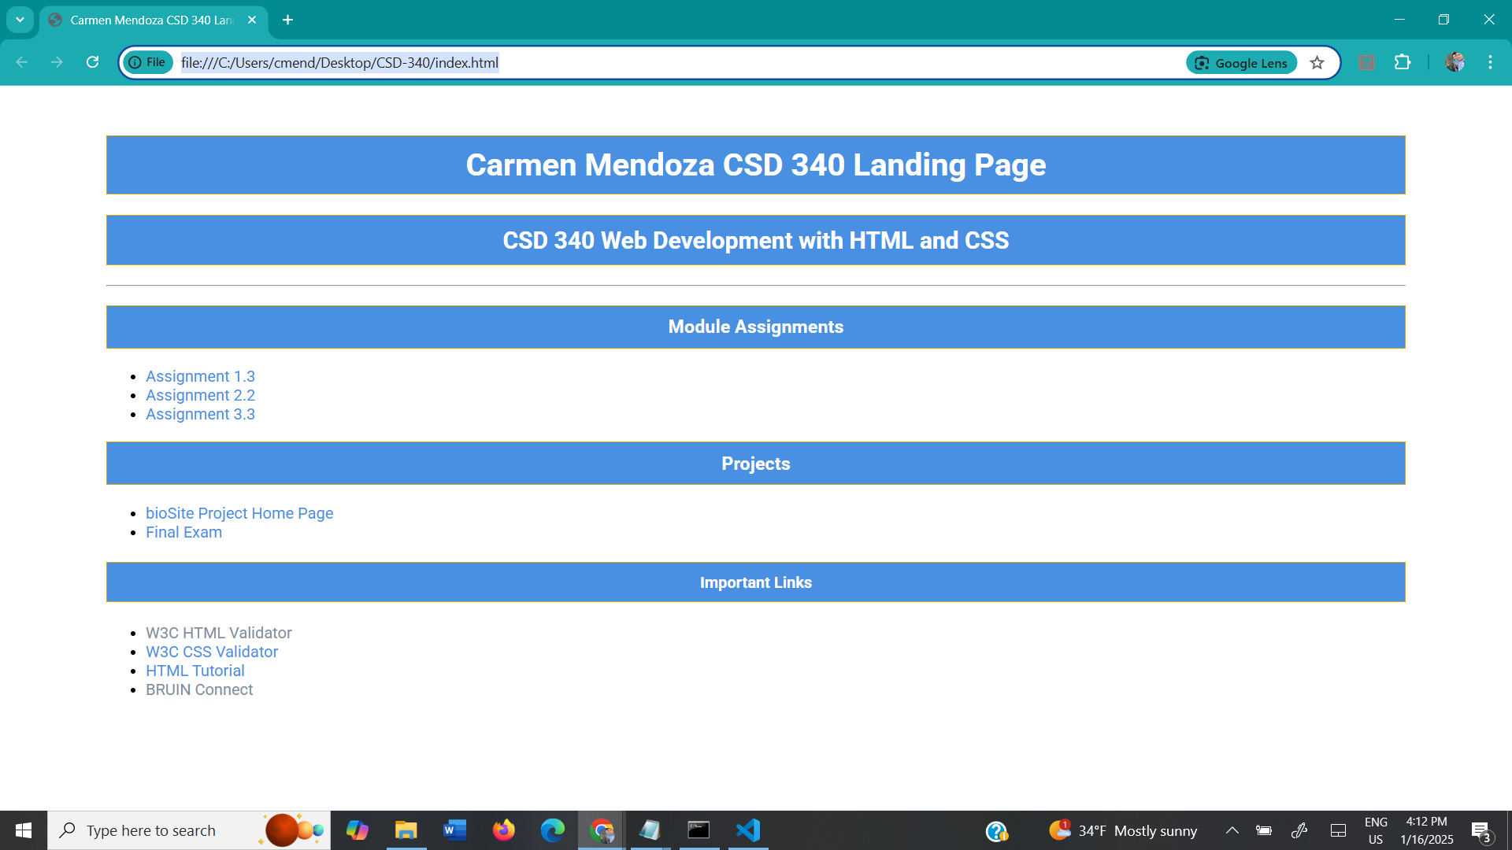

Link to browser: file:///C:/Users/cmend/Desktop/CSD-340/module-3/index.html